Moodle: How to use the Attendance activity (Students)

This document provides step-by-step instructions students who need to self-record attendance using the Moodle Attendance activity.

How to Self-Record Attendance 1
How to View Total Number of Absences 3

How to Self-Record Attendance

NOTE: Students must self-record attendance during the first 10 minutes of the class period. If a class meets from 9:10 a.m. until 10:10 a.m., attendance must be recorded by 9:20. Students must also comply with attendance rules described in the course syllabus. Note that the syllabus may narrow the window during which attendance may be recorded.

- Once you have logged in to Moodle and opened the class you are attending, locate the Attendance Activity and click Attendance.

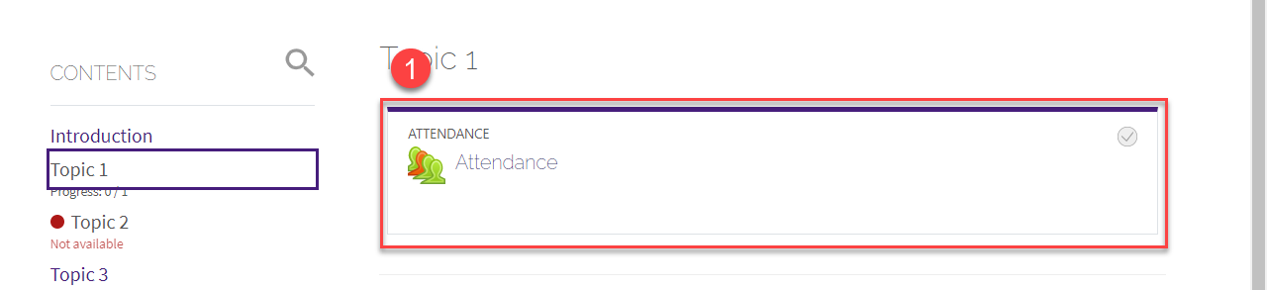
- Click Submit Attendance
- Select Present
- Click Save
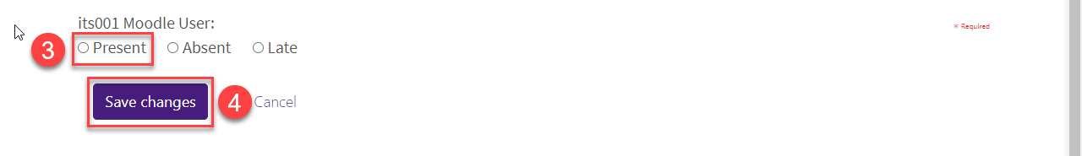
- Confirm attendance was recorded on the following screen
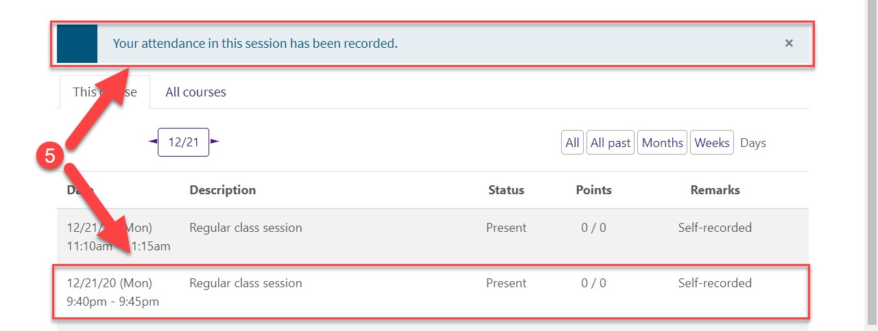

How to View Total Number of Absences
- Once you have logged in to Moodle and opened the class you are attending, locate the Attendance Activity and click Attendance.
- Absences will be displayed in this column.
